Bloom’s Taxonomy

bLOOM’S tAXONOMY
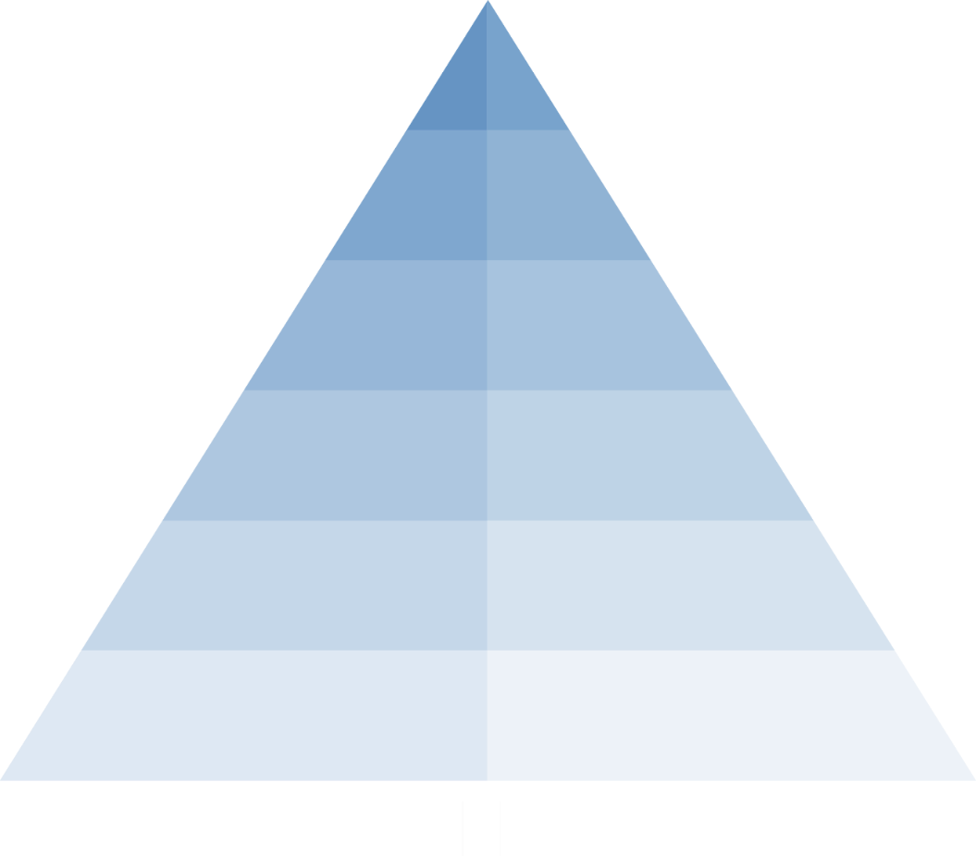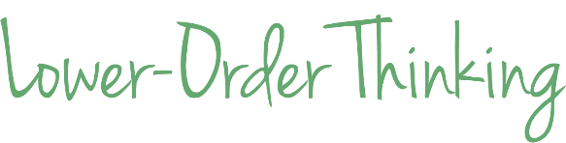

SAMPLE VERBS ACCORDING TO bLOOM’S TAXONOMY
1. Remember | 2. Understand | 3. Apply | 4. Analyze | 5. Evaluate | 6. Create
Remember Information | Explain Ideas or Concepts | Use Information in a New Way | Distinguish Between Parts | Justify a Position or Decision | Create a New Product or Point of View
Choose  Define  Find  Identify  Label  List  Match  Name  Recognize  Recall  Select  Tabulate | Classify  Compare  Describe  Estimate  Explain  Illustrate  Infer  Interpret  Measure  Outline  Report  Summarize | Apply  Build  Calculate  Construct  Demonstrate  Develop  Graph  Model  Organize  Practice  Solve  Use | Analyze  Attribute  Break down  Categorize  Determine the relationship  Differentiate  Examine  Group  Organize Separate  Simplify | Argue  Assess  Conclude  Create  Criticize  Decide  Deduct  Defend  Judge  Predict  Prioritize  Support | Adapt  Build  Combine  Design  Develop  Generate  Integrate  Modify  Plan  Produce  Theorize  Validate

Moody, Michael, and Jason Stricker. Strategic Design for Student Achievement. New York: Teachers College Press, 2008.

