INTRODUCTION TO ASSESSMENT DESIGN

INTRODUCTION AND PURPOSE
By the end of this module, you should be able to define several key terms and concepts that are foundational to this series of modules—including what the modules identify as five elements of assessment design and validity and reliability—and explain why teachers should focus on these five elements of assessment design and not the statistical concepts associated with validity and reliability as researchers and test makers apply them. You will also be able to explain the purpose of two tools that the Toolkit introduces: an assessment blueprint template and an assessment blueprint filled out with an example.

KEY CONCEPTS

Classroom Assessments
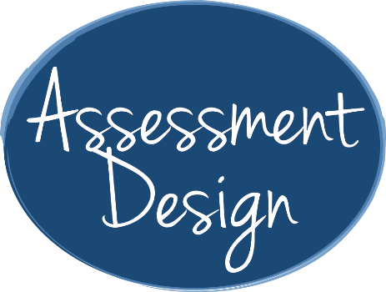
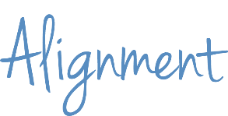
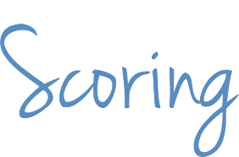
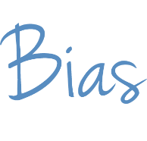
“Assessment” refers to processes and tools that measure what students know and can do. In this series of modules, we focus on a type of assessment that is more formal than these daily checks for understanding but less formal than, for example, an annual State test. We focus on assessments that you design for students in your classroom. For the purposes of these modules, “assessment design” is a term that includes planning, writing and selecting assessments. We consider assessments to be well designed if they provide an accurate and consistent measure of what students know and can do. To determine whether your classroom assessments are well designed, you can consider what we’re calling the “five elements of assessment design.”

Five Elements of Assessment Design
The five elements of assessment design that we discuss in these modules are alignment, rigor, precision, bias and scoring.
- An assessment that is aligned with standards measures student performance against those standards.
- An assessment has an appropriate level of rigor if the assessment includes assessment items that match the level of rigor of the skill or skills you intend to measure and the assessment measures a range of student thinking and understanding so that it measures what all students know and can do.
- A precise assessment measures students’ knowledge and skills, not their misinterpretations or lack of unrelated background knowledge.
- An unbiased assessment measures students’ knowledge and skills, not differences among groups of students because of their personal characteristics, such as race, gender, socioeconomic status or religion.
- An assessment that has an appropriate scoring strategy measures students’ knowledge and skills, not how or when the assessment is scored or who scores it.

Validity and Reliability
Validity refers to the accuracy of an assessment—the extent to which it measures what you intend it to measure. Reliability refers to an assessment’s consistency—the extent to which a student’s score will be the same no matter when, where or in what form the student takes the assessment or who scores it—whether it’s you or the teacher down the hall. Validity and reliability are terms that researchers and test makers often use in association with precise statistical definitions and large-scale standardized tests, such as the SAT or assessments used for school accountability. The psychometric discipline of designing valid and reliable large scale assessments is not easily replicated when educators are designing assessments for smaller scales of use, such as the classroom or school.

Assessments that you use in your classroom are smaller in scale and do not demand the same level of scrutiny, but you can consider the five elements of assessment design that we introduced earlier to ensure that your classroom assessments are as valid and reliable as possible. Once you master how to address these five elements, you will be able to plan, write and select assessments that have an appropriate level of validity and reliability for use in your classroom.

How to Use the Assessment Blueprint and Assessment Blueprint Example
Throughout this series of modules, we use two tools—the assessment blueprint and assessment blueprint example—to help you organize the concepts. The assessment blueprint we use in this series of modules includes a table with directions and a blank template that you can repurpose to design your own assessments. The steps in the blueprint show a process of backward design, in which you first determine which standard or standards you plan to measure; second, design your assessment to measure mastery of the standard or standards; and third, plan your instruction.

CHECK FOR UNDERSTANDING

Assessment Items
- Discuss in one to three sentences why we recommend that you focus on five elements of assessment design as opposed to the statistical concepts associated with validity and reliability.

- What are the assessment blueprint and assessment blueprint example, and how will you use them to understand the concepts in this series of modules and plan assessments in the future?

Answers
- Discuss in one to three sentences why we recommend that you focus on five elements of assessment design as opposed to the statistical concepts associated with validity and reliability.
Assessments that I use in my classroom do not demand the same level of statistical scrutiny as large-scale, standardized tests, but I can consider five elements of assessment design to ensure that my assessments are reasonably valid and reliable. Once I master how to address these five elements, I will be able to plan, write and select assessments that have an appropriate level of validity and reliability for use in my classroom.

- What are the assessment blueprint and assessment blueprint example, and how will you use them to understand the concepts in this series of modules and plan assessments in the future?
The assessment blueprint and the assessment blueprint example are tools to help me organize the concepts in this series of modules. The assessment blueprint includes a table with directions and a blank template that I can repurpose to design my own assessments. The assessment blueprint example is the template filled out with an example. I can use the tools in my teaching practice to help me determine which standard or standards I plan to measure and design assessments to measure mastery of the standard or standards before I begin teaching.

To create this list, we synthesized information from several sources: Kansas State Department of Education, Assessment Literacy Project; Ohio Department of Education, “Assessment Literacy: Identifying and Developing Valid and Reliable Assessments” (2013); Relay Graduate School of Education, Designing and Evaluating Assessments (2014); and Rhode Island Department of Education, “Deeping Assessment Literacy.”
Kansas State Department of Education, Assessment Literacy Project and Ohio Department of Education, “Assessment Literacy: Identifying and Developing Valid and Reliable Assessments” (2013).
Adapted from Ohio Department of Education, “Assessment Literacy: Identifying and Developing Valid and Reliable Assessments” (2013).
Moody, Michael, and Jason Stricker, Strategic Design for Student Achievement (2008).

