Guiding Questions for Leading Formative Assessment
This template offers guiding questions for leaders involved in supporting formative assessment implementation. The questions are aligned with the five principles in the Formative Assessment Leadership Framework.

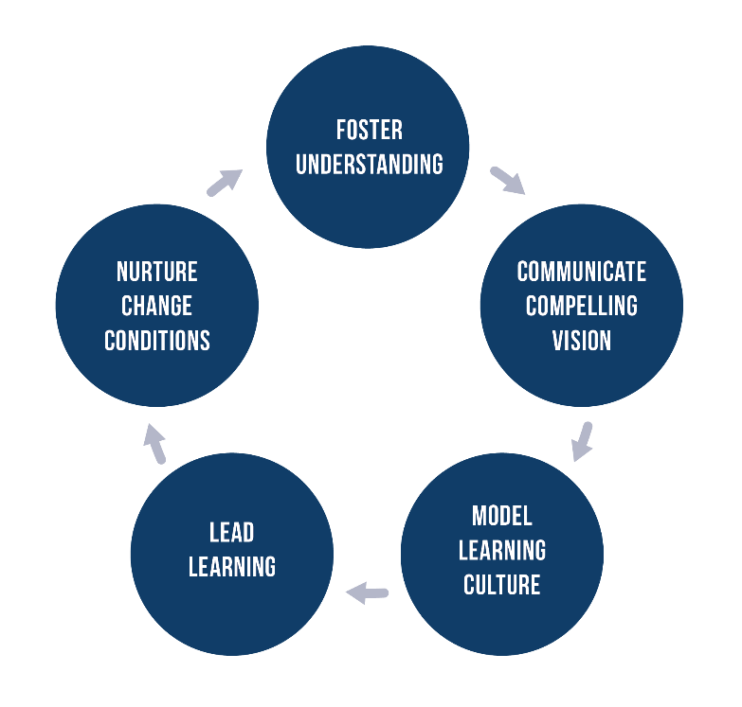

Foster Understanding

How will I approach my own learning to develop expertise in formative assessment and to better understand how teachers and student learn to use formative assessment?
How can I best leverage others (the district, my peers, my teachers or my students) to support my own learning?
What are 2 or 3 strategies I can use to begin to foster shared understanding about formative assessment among my faculty, and within my community?

Communicate a Compelling Vision of Formative Assessment

The next time someone asks me why we are engaged in formative assessment, what will I say to communicate my vision?
Who is in my sphere of influence? Who needs to know my vision of formative assessment?
What do I need to communicate about formative assessment to those in my sphere of influence? How will I address typical barriers to implementation, such as people believing they already do this, or that this is “just good teaching”?

Model a Learning Culture

If I consider the continuum between having an “accountability” oriented culture to having a “learning” culture, where would I place my school along that continuum? What evidence lead me to consider this placement?
What structures will I put in place, as school begins, in order to routinely notice and respond to emerging knowledge and understanding of formative assessment?
What are ways I can contribute to developing trust among those in my sphere of influence in order to lessen the inherent risk in sharing emerging understanding?

Lead the Learning

How will I ensure teachers have adequate time and opportunity to learn formative assessment? Who else needs to be involved in identifying scheduled time for learning? Who will lead professional learning?
How do I best communicate to teachers the need for daily learning and application in formative assessment? What metaphors or stories could I tell to encourage and support daily practice?
What are my plans to create and engage in learning opportunities, such as peer observations, model lessons, or video study, that encourage dialogue about the student role in learning?

Nurture the Conditions for Change and Sustainability

As I begin this year, what will I do to leverage early adopters and those who are passionate about this work to support change? How will I create opportunities for my teachers to learn from those who have been in the pilot?
Who can be an ambassador for this work? How can I support their ambassadorship?

