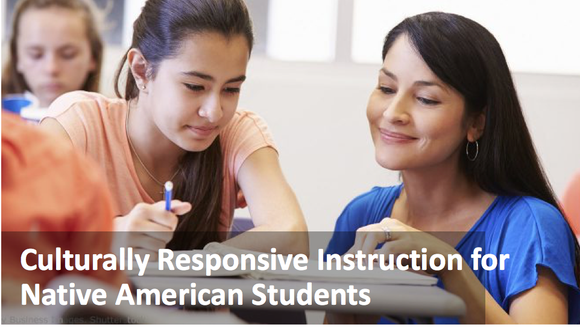

**Guidelines: materials, curriculum,**

**parent & community involvement, scaffolding**

**Handout for Teachers**

|  |
| --- |
| Application Activity |

**Directions - part 1**

1. Choose an upcoming lesson to apply culturally responsive principles you’ve just learned.
2. In the lesson overview section below, state the lesson learning goals and and the general flow of lesson activities.

|  |
| --- |
| Lesson overview: |

1. In the column below labeled “CRI principles in original lesson,” list and describe how the lesson incorporated any of the CRI principles you just learned about (instructional materials, curriculum, parent and community involvement, and scaffolding). CRI guidelines are provided in the left hand column and at the end of the worksheet for your reference.
2. In the column “Culturally responsive revisions,” describe how you would change the lesson to make it more culturally responsive. Try to include at least one CRI principle in each of the categories below.

|  |  |  |
| --- | --- | --- |
|  | CRI principles in original lesson | Culturally responsive revisions |
| **CRI Instructional Materials**   * *Represent Native American authors* * *Are consistent with Native American epistemologies* * *Connect with students lives and communities* |  |  |
| **CRI Curriculum**   * *Connect global and national levels to local level: information, events and issues* * *Incorporate Native experience: culture, history, politics, legal status, current affairs* * *Provide opportunities for students to participate in critique* * *Examine for inclusivity, bias, stereotyping, and omission* |  |  |
| **CRI Parent and Community Involvement**   * *Include community members in classroom planning and activities* * *Arrange for students to go out to the community for field trips, to conduct projects, and engage community members in coursework* |  |  |
| **Scaffolding**   * *Identify what schooling practices students are/are not familiar with.* * *Consider scaffolding:*   + *Participant/communication structures, e.g., Socratic Seminars, debates, peer feedback*   + *Language of schooling - speaking, listening, reading, and writing, e.g., academic texts, formal presentations* |  |  |

**Directions - part 2**

1. **Teach the lesson!**
2. Reflect on the lesson. How well did the lesson work? How did your Native American students respond to the changes you made? What did you notice about how incorporating the principles may have influenced, if at all, the process and effectiveness of the lesson (e.g., your and student roles, student engagement levels, learning success)?

|  |
| --- |
|  |

1. What would you do differently next time?

|  |
| --- |
|  |

**Culturally Responsive Instruction Guidelines - At a Glance**

|  |  |
| --- | --- |
| **Instructional Materials**   * Represent Native American authors * Are consistent with Native American epistemologies * Connect with students lives and communities | **CRI Parent and Community Involvement**   * Include community members in classroom planning and activities * Arrange for students to go out to the community for field trips, to conduct projects, and engage community members in coursework |
| **CRI Curriculum**   * Connect global and national levels to local level: information, events and issues * Incorporate Native American experience: culture, history, politics, legal status, current affairs * Provide opportunities for students to participate in critique * Examine for inclusivity, bias, stereotyping, and omission | **Scaffolding**   * Identify what schooling practices students are/are not familiar with. * Consider scaffolding:   + Participant/communication structures, e.g., Socratic Seminars, debates, peer feedback   + Language of schooling - speaking, listening, reading, and writing, e.g., academic texts, formal presentations |