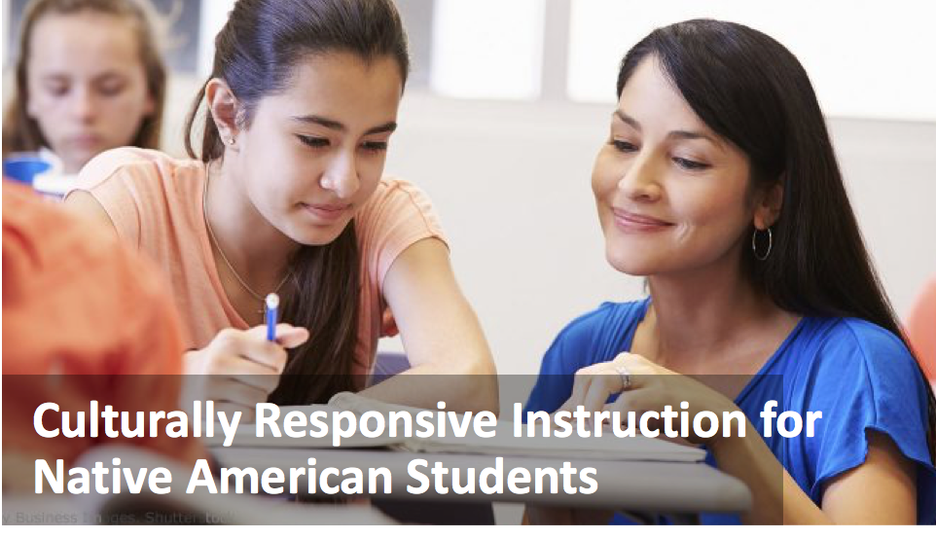

Initial Guidelines

Handout for Teachers

|  |
| --- |
| Application Activity |

**Directions - part 1**

1. Think of a lesson you taught recently that is typical of your classroom practice.
2. In the lesson overview section, state the lesson objectives and the general flow of lesson activities.

|  |
| --- |
| Lesson overview: |

1. In the column below labeled “CRI principles in original lesson,” describe how the lesson incorporated any of the CRI principles you just learned about (instructional strategies, activities, types of social interactions, and your attitude towards students). CRI guidelines are provided in the left hand column and at the end of the worksheet for your reference.
2. In the column “Culturally responsive revisions,” describe any changes you could make in the lesson to make it more culturally responsive.

|  |  |  |
| --- | --- | --- |
|  | CRI principles in original lesson | Culturally responsive revisions |
| **CRI Instructional Strategies**   * *Give students choice* * *Incorporate modeling and demonstration* * *Use storytelling, parable, allegory and example* |  |  |
| **CRI Instructional Activities**   * *Provide authentic contexts* * *Include local, place-based projects and assignments* * *Foster active, hands-on learning* |  |  |
| **CRI Social Interactions**   * *Be cautious of “spotlighting” students* * *Use a demanding but warm style* * *Get familiar with local, cultural norms for public displays of affection and other norms of interaction* |  |  |
| **Attitude Toward Students**   * *Caring, warm, approachable, supportive, flexible, show respect for students, expect excellence* |  |  |

**Directions - part 2**

1. Repeat the above process for an upcoming lesson.

|  |
| --- |
| Lesson overview for upcoming lesson: |

|  |  |  |
| --- | --- | --- |
|  | CRI principles in original lesson plan | Culturally responsive revisions and plan |
| Instructional strategies |  |  |
| Instructional activities |  |  |
| Social interactions |  |  |
| Attitude toward students |  |  |

1. **Teach the lesson!**
2. Reflect on the lesson. What changes did you notice (e.g., student role) after incorporating CRI elements as compared to other, similar lessons?

|  |
| --- |
|  |

1. What would you do differently next time?

|  |
| --- |
|  |

**Culturally Responsive Instruction Guidelines - At a Glance**

|  |  |
| --- | --- |
| **Instructional Strategies**  Give students choice  Incorporate modeling and demonstration  Use storytelling, parable, allegory and example | **Norms of Social Interactions**  Be cautious of “spotlighting” students  Use a demanding but warm style  Get familiar with local, cultural norms for public displays of affection and other norms of interaction |
| **Instructional Activities**  Provide authentic contexts  Include local, place-based projects and assignments  Foster active, hands-on learning | **Teacher Attitudes**  Caring, warm, approachable, supportive, flexible, show respect for students, expect excellence |